Module 3: Module 3: Benefits, Provisions, and Ownership Rights

Lesson 2: Life Insurance Policy Provisions

Learning Objectives

After studying this lesson, you will be able to:
- Identify and list the documents that make up the entire contract between the owner of an individual life insurance policy and the insurer.
- Describe the free-look provision of a life insurance policy.
- Explain the purpose and operation of the incontestability provision.
- Describe the terms of the standard grace period provision.
- Identify situations in which a life insurance policy can be reinstated and the conditions the policyowner must meet to reinstate the policy.
- Determine the action an insurer likely will take if it discovers a misstatement of the age or sex of the person insured by a life insurance policy.
- Describe the policy loan provision and the policy withdrawal provision of cash value life insurance policies.
- Identify and describe the nonforfeiture options typically included in cash value life insurance policies.
- Identify the exclusions that insurers sometimes include in individual life insurance policies.

Life Insurance Policy Provisions

Learning Objective
Identify and list the documents that make up the entire contract between the owner of an individual life insurance policy and the insurer.
Describe the free-look provision of a life insurance policy.
Open Transcript
Open Transcript

Entire Contract Provision
The entire contract provision prevents oral statements or other documents not identified in the entire contract provision from being used to challenge the terms of the contractual agreement.
What documents do you think are defined in an entire contract provision?


Closed and Open Contracts
The answer depends on whether the policy is a closed contract, which is issued by a stock or mutual insurer, or an open contract, which is issued by a fraternal insurer.
- Closed contract—only terms printed in or attached to the contract are part of the contract.
- Open contract—documents that are considered part of the contract are not all attached to it.

Entire Contract Documents
Documents that make up the entire contract for a life insurance policy:
Closed contract life insurance policy
- Insurance policy
- Policy riders
- Application for insurance
Open contract life insurance policy
- Insurance policy
- Policy riders*
- Membership application*
- Declaration of insurability*
- Fraternal Charter, Constitution, and By-laws**
*These documents are typically attached to the policy contract
** When a person becomes a member of a fraternal society, he receives a copy of the society’s charter, constitution, and bylaws. For this reason, when a fraternal issues a life insurance policy, these documents are not attached to the policy.
(Below, click or touch the arrows to the right.)

"Actually, there is, Mr. Mascali. Your policy includes a 10-day free-look provision.
The free-look provision gives you 10 days to examine the policy from the date the policy is delivered; your coverage is in effect the whole time, but you can still cancel the policy and get a full refund."

Free-Look Provision
Free-look provision: gives policyowner 10 days from policy delivery date to examine the policy. During free look:
- Policyowner can cancel for a full refund of initial premium
- Coverage is in effect

Peter Hay owns a life insurance policy issued by Azure Life, which issues only closed contracts. Choose all of the documents that constitute the entire contract between Peter and Azure.
^{The policy}
The brochure describing the policy
- The attached application for insurance
- Any riders attached to the policy
- The canceled check for the initial premium payment.
Answer: The policy, The attached application for insurance, Any riders attached to the policy
The entire contract for Peter’s policy consists of the policy, any attached riders, and the attached copy of the application for insurance.
Submit
When a policyowner wishes to cancel an insurance policy during the free-look period, the insurance coverage is
- ^{Not in effect}
- In effect, and the policyowner receives a partial refund of the initial premium payment
- In effect, and the policyowner receives a full refund of the initial premium payment.
A free-look provision gives a policyowner a stated time period—usually 10 days—to examine a newly delivered policy. During the free-look period, the policyowner can cancel the coverage and receive a refund of the entire initial premium paid.

Incontestability Provision

Learning Objective
Explain the purpose and operation of the incontestability provision.
Claim analyst, Trip Danville, is concerned about a life insurance policy claim. It looks like the policyowner gave incorrect information when he filled out the application.
Can the insurer do anything about that?
It depends.
Let’s explore further…

Material Misrepresentation
Recall the underwriting process and how the proposed insured answers questions which help the underwriter decide whether or not to issue the insurance policy. Sometimes people make misrepresentations in their applications.
If the insurer would not have issued the policy or would have issued the policy on a different basis, such as with a higher premium or lower face amount, had the truth been known, then the misrepresentation is a material misrepresentation.
When a material misrepresentation is found in an application, the insurer can ask a court to void the policy on the basis that no valid contract ever existed.


Can you tell what makes a misrepresentation material? Select each example that represents a material misrepresentation. (Choose all that apply.)
Denise Rand’s application indicated that she broke her left leg. Actually, it was her right leg.
Jack Anthony’s application stated that, on August 20th, he had a routine physical. Actually, he was being treated for heart disease.
Sam Prada’s application stated that he had seen the doctor on January 9th. Actually, it was January 10th.
Morty Brennan’s application indicated that he saw the doctor for treatment of a skin condition. Actually, he was being treated for diabetes.
Submit

Incontestability Provision
Insurance contracts limit the time during which an insurer can avoid a contract on the basis of material misrepresentation. A policy’s incontestability provision describes this time limit.
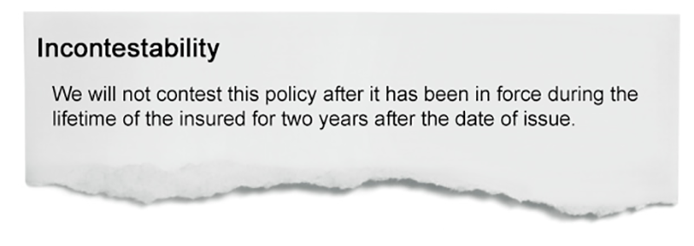
Image Description
This incontestability provision contains an important phrase. Do you know what it is?
What’s so important about “during the lifetime of the insured?”

Without this phrase, if the insured died during the contestable period (two years after policy issue), the beneficiary could wait until after the contestable period expired to submit a claim. The insurer might never be able to contest the policy, even if the application contained a material misrepresentation.
Including “during the lifetime of the insured” makes the policy contestable forever as long as the insured dies during the contestable period.

Incontestability Period
A two-year contestable period is typical, although shorter contestable periods are allowed.
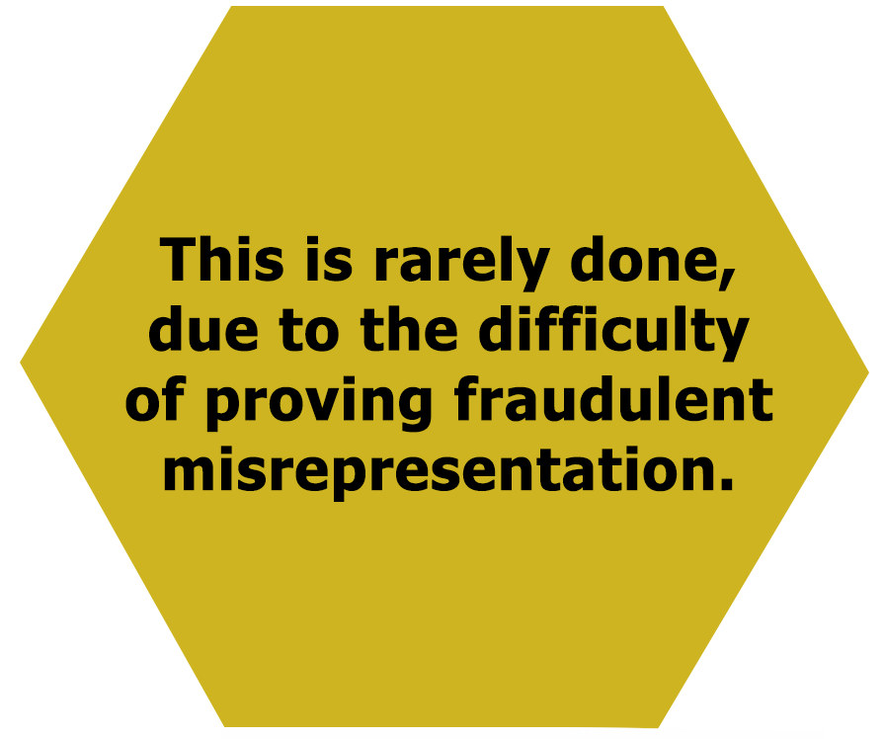
Exception
Under the laws of most states, an insurer can contest the policy for fraudulent misrepresentation at any time.

Remember Jack Anthony, who said he had a routine physical but was actually being treated for heart disease? Well, Jack died five years after buying a policy with a typical incontestability provision. While processing the claim, the insurer discovered the material misrepresentation in Jack’s application.

What do you think happened with Jack’s claim?
The insurer denied the claim for life insurance benefits
The insurer paid only a portion of the death benefit to the beneficiary
The insurer paid the full amount of the death benefit to the beneficiary
^{I’m not sure.}
In his application for a life insurance policy with the Star Life Insurance Company, Louis Kahn indicated no disease or disorder of the lungs. In fact, Mr. Kahn was being treated for tuberculosis. Star issued Mr. Kahn the policy, which contained a typical incontestability provision.

Mr. Kahn died from tuberculosis one year after the policy was issued and his beneficiary promptly submitted a claim. Star discovered the material misrepresentation while evaluating the death claim. In this case, the contestable period
^{Has expired}
^{Has not expired}
In this situation, Star most likely
^{Must pay the death benefit}
^{Can avoid the contract}

Grace Period and Reinstatement

Learning Objective
Describe the terms of the standard grace period provision.
Identify situations in which a life insurance policy can be reinstated and the conditions the policyowner must meet to reinstate the policy.
Open Transcript

Grace Period Provision

Grace period provision—Gives the policyowner a stated number of days—typically, 30 or 31—after the renewal premium due date to pay and the policy remains in force.
- The coverage is in effect during the grace period
- If premium is not paid by end of grace period, the policy lapses

What happens if the insured dies during the grace period without having paid the premium that was due?
The insurer denies the claim and pays nothing to the beneficiary.
The insurer denies the claim but returns all premiums paid for the coverage.
The insurer pays the claim after deducting the amount of the unpaid premium from the benefit payable.
(Click or touch the arrows to the right.)

A few minutes later, Gloria gets another call... "Hi, my name is Gloria. How can I help you?"
- In a universal life policy, the grace period provision applies when the cash value is insufficient to meet policy’s monthly mortality and expense charges.

For Sol Mirren’s policy, the grace period began on the date the policy’s cash value was less than the entire mortality and expense charge. In this type of policy the grace period continues for 61 or 62 days. Other UL policies have a different grace period provision. The grace period begins when the cash value is zero and lasts for 30 or 31 days.
So, for a UL policy, if the grace period starts when the
- Cash value is less than the mortality and expense charge, then the grace period is 61 or 62 days
- Cash value equals zero, then the grace period is 30 or 31 days
For either type, at least 30 or 31 days before the coverage expires, the insurer must notify the policyowner that coverage will terminate if the policyowner does not pay enough to cover the policy charges due.

Reinstatement
(Click or touch the arrows to the right.)

"Customer Service, this is Gloria."
Reinstatement: Putting a terminated policy back in force. No new policy.
Reinstatement provision: Describes the requirements for reinstating a policy.

Which condition usually is necessary for reinstatement?
The policyowner MUST have surrendered policy.
The policyowner MUST NOT have surrendered policy.
The policyowner MUST NOT have a policy loan outstanding.
(Click or touch the arrows to the right.)

"Let me pull up your old policy. I see you did not surrender the policy for its cash value. If you had, we could not reinstate it. "
- Original policy usually cannot have been surrendered
- Policy loan must be repaid or reinstated

To reinstate a policy, the original policy usually cannot have been surrendered and any outstanding policy loans must be repaid or reinstated with the policy. Any other requirements?
Yes, the beneficiary of the reinstated policy must be the same as original policy.
Yes, the insured must provide evidence of insurability.
Yes, the policyowner’s home address must be the same as before.
^{No, that’s all.}
(Click or touch the arrows to the right.)

"Yes, you will need to complete a reinstatement application and give us evidence that you’re still an insurable risk. If you’re approved, the contestability period begins again. "
Policyowner must
- Complete the reinstatement application
- New contestability period based only on information in reinstatement
- Provide new evidence of insurability

Once a policyowner completes the reinstatement application and provides new evidence of insurability, what else is needed to complete the policy’s reinstatement?
The policyowner has to pay all missed premiums.
The beneficiary has to agree in writing to reinstatement.
(Click or touch the arrows to the right.)

"The big requirement is that you’ll need to pay money to bring your policy to the same financial position it would have been in if you’d been paying premiums all this time."
Fixed-premium policy—Policyowner must pay all missed premiums plus interest
Flexible-premium policy—Policyowner must pay the mortality and expense charges for a stated amount of time
Why must the policyowner pay back premiums with interest?
To bring the policy reserve to the same level as for a similar policy that had been kept in force all along.


What are policy reserves?
Policy reserves are amounts of money that an insurer projects it will need to pay its future obligations to customers.
Insurance laws require insurers to establish policy reserves so that they’ll be able to pay policy benefits when the benefits come due.

Advantages of Policy Reinstatement
A policyowner must decide whether reinstating the original policy or purchasing a new policy is more advantageous.
Some advantages of reinstating a fixed-premium policy are
- Premium rate is based on the insured’s age at original policy’s purchase date
- Original policy’s cash value is reinstated
- Original policy may contain more liberal provisions than do insurer’s current policies. Example: The interest rate for a policy loan may be lower under the original policy than for the new policy.

Marla Ross is the policyowner-insured of a $50,000 term life policy. The policy’s annual renewal premium is due on May 1. The policy contains a 31-day grace period provision.

If Marla dies on May 15 without having paid the renewal premium due, the insurance company will deduct the amount of the unpaid renewal premium from the policy’s proceeds.
^{True}
^{False}
Marla Ross’s sister Janine is the policyowner-insured of a universal life policy. Janine has not made a premium payment in four years; the insurer has used the policy’s cash value to pay the monthly mortality and expense charges. On June 1, the cash value of Janine’s policy is zero. The grace period for Janine’s policy begins on that date.

Beginning on June 1, Janine will have how many days to make a premium payment to cover the charges and keep the policy from lapsing?
^{15 days}
^{30 or 31 days}
^{61 or 62 days}
If Janine from the previous example dies during the grace period without having made a payment, the insurer will deduct the amount of overdue charges from the policy proceeds.
^{True}
^{False}
Select each true statement about the reinstatement provision. (Choose all that apply)
Reinstatement usually isn’t available if policy was surrendered for its cash value
Reinstatement puts original policy back in effect; insurer does not issue a new policy
Conditions to reinstate include completing a reinstatement application, providing evidence of insurability, paying a specified amount of money, and repaying any policy loan plus interest (or reinstatement of loan with the policy)

Misstatements

Learning Objective
Determine the action an insurer likely will take if it discovers a misstatement of the age or sex of the person insured by a life insurance policy.

Misstatement of Age or Sex Provision

Sometimes people make simple mistakes when they fill out an insurance application and enter their age or sex incorrectly. Age and sex are significant factors that insurers use to determine the amount of premium to charge for a life insurance policy.
The misstatement of age or sex provision describes how an insurer adjusts the policy benefit if the age or the sex of the insured is incorrectly stated.
How do you think the insurer handles such misstatements?

Discovery of Misstatement
(Click or touch each tab below.)
Before Death
After Death

Seamus Rafferty was the policyowner-insured of a $100,000 whole life insurance policy issued by the Shamrock Life Insurance Company. The application lists Mr. Rafferty’s age as 45. While processing Mr. Rafferty’s death claim, Shamrock discovered he was actually 50 when he purchased the policy.

To account for the misstatement of Mr. Rafferty’s age, Shamrock most likely will pay the beneficiary an amount that is
Less than the policy’s face amount
More than the policy’s face amount
Antoinette Childe is the policyowner-insured of a $100,000 whole life insurance policy issued by Shamrock. Shamrock has recently discovered that Ms. Childe overstated her age by 5 years on her insurance application. Ms. Childe is still alive.

Shamrock most likely will refund Ms. Childe an amount that is equal to the difference in premiums paid and what she should have paid had her age had been stated correctly on the application.
^{True}
^{False}

Loans, Withdrawals, Nonforfeiture Options

Learning Objective
Describe the policy loan provision and the policy withdrawal provision of cash value life insurance policies.
Identify and describe the nonforfeiture options typically included in cash value life insurance policies.
Identify the exclusions that insurers sometimes include in individual life insurance policies.
Open Transcript

Policy Loan Provision
The policy loan provision allows the policyowner to borrow up to the amount of the policy’s cash value less one year’s interest on the loan.
A policy loan is actually an advance payment of part of the policy benefit amount.


Policy Loan Features

Features of Policy Loans:
- Only applicable to cash value policies
- The insurer does not do a credit check
- The insurer charges interest, usually annually
- The interest rate may be fixed or may vary with economic conditions (often guaranteed not to be more than a stated maximum rate)
- No repayment schedule for policy loan balance or accrued interest
- The insurer subtracts any outstanding loan balance plus accrued interest from the death benefit or cash surrender value
Open Transcript

Policy Withdrawal Provision

A policy withdrawal provision allows the owner of a universal life policy to withdraw up to the amount of the cash value of the policy.
- No interest charged
- Cash value is reduced by the amount of the withdrawal
- Withdrawal fee may be charged
- Number of withdrawals each year may be limited

Amanda Kensington has taken out a policy loan. Select each true fact about this situation.
Amanda is legally obligated to repay the loan.
The insurance company charges interest on the loan.
The insurance company performed a credit check on Amanda before approving the policy loan.
Amanda Kensington from our previous example is insured by a $50,000 cash value life insurance policy. Disregarding any accrued interest, if Amanda dies with a policy loan of $4,000 outstanding, what death benefit will the policy’s beneficiary receive?
^{$46,000}
^{$50,000}
^{$54,000}
When the owner of a universal life insurance policy takes a policy withdrawal, the insurer charges interest on the withdrawal.
^{True}
^{False}

Nonforfeiture Provision
Sometimes the owner of a cash value policy decides he no longer wants or needs insurance. What happens to any cash value?
The nonforfeiture provision provides options to such a policyowner when coverage terminates through policy lapse or surrender.
Most policies have an automatic nonforfeiture benefit if the owner hasn’t chosen an option when a policy lapses.


Net Cash Surrender Value
The amount of cash value available to the policyowner when coverage terminates is the net cash surrender value.
Insurers calculate the net cash surrender value by adjusting the cash value as follows:
The cash value of any paid-up additions
Any premiums paid in advance
Any accumulated policy dividends
Minus any policy loans and policy loan interest outstanding
Example of a net cash surrender calculation
Lindsey Alexander wants to surrender her whole life insurance policy for its net cash surrender value. The cash value of her policy is $5,000, and the cash value of the paid-up additions she’s purchased is $150.
Lindsey also has accumulated $250 in policy dividends, has made an advance premium payment of $200, and has an outstanding policy loan plus interest of $1,000.
Analysis
The net cash surrender value payable to Lindsey is $4,600:
$5,000 Cash value amount listed in policy
+ 150 Cash value of paid-up additions
+ 250 Amount of policy dividend accumulations
+ 200 Amount of advance premium payment
-1,000 Policy loan, plus interest, outstanding
$4,600 Net cash surrender value

What do you think happens to a policy’s insurance coverage when the policyowner elects to receive the cash payment nonforfeiture option?
The insurance coverage continues in a reduced amount.
The insurance coverage continues for a specified period of time.
^{The insurance coverage ends.}

Other Nonforfeiture Options

Many policies that build a cash value provide the policyowner with the option of discontinuing premium payments and continuing insurance coverage.
The reduced paid-up insurance nonforfeiture option allows the policyowner to discontinue paying premiums and use the policy’s net cash surrender value to purchase paid-up life insurance of the same plan as the original policy.
The extended term life insurance nonforfeiture option allows the policyowner to discontinue paying premiums and use the policy’s net cash surrender value to purchase term insurance. This term insurance is for the full coverage amount provided under the original policy for as long a term as the net cash surrender value can provide.

Extended Term vs. Reduced Paid-up
See as this expert industry explains his company's experience with extended term insurance and reduced paid-up insurance.
Open Transcript

Automatic Premium Loan
Many cash value policies also include an automatic premium loan option. The insurer will automatically pay an overdue premium by making a loan against the policy’s cash value, as long as the cash value equals or exceeds the amount of premium due.
Using this option keeps the original policy, including all supplemental benefits, in force.

Life Insurance Policy Exclusions

Insurance policies exclude certain causes of death from policy coverage. The most common exclusion is death by suicide for a specified period—usually two years—from the date of policy issue.
The suicide exclusion provision governs the payment of a policy’s proceeds if the insured dies by suicide.
If suicide occurs during the exclusion period, the insurer pays no death benefit but does refund the premiums paid. If suicide occurs after the exclusion period, the insurer pays the policy’s full death benefit.

Suicide Exclusion
See as this industry expert explains why a suicide exclusion is a necessary part of a life insurance policy.
Open Transcript

Other Exclusions
Insurers sometimes include other exclusions in life insurance policies. These exclusions include
- War exclusion clauses—proceeds not paid if death results from war
- Hazardous activities exclusion provisions—proceeds not paid if death resulted from specific dangerous activities, such as sky diving or scuba diving
- Aviation exclusion provisions—proceeds not paid if death resulted from aviation-related activities
These rarely appear in today’s policies.

Aviation Exclusion
Insurers may apply an aviation exclusion if the insured engages in military aviation, pilots experimental aircraft, or is a pilot or crew member on a privately owned plane.


When a policy’s automatic premium loan (APL) provision is activated, the insurer automatically pays an overdue premium by making a loan against the policy’s cash value until the insured dies, regardless of when death occurs.
^{True}
^{False}
Select the causes of death that life insurance policies might exclude from coverage. Choose all that apply.
Death resulting from suicide 6 months after policy issue
^{Death as a result of war}
Death resulting from mountain climbing
Death of a passenger on a commercial airplane that crashed
Death of the pilot of a private airplane
Death resulting from suicide within 3 years of policy issue

